Project Design Phase-II
Data Flow Diagram & User Stories
Date | 28 September 2026
Team ID | SWTID-2026-5228
Project Name | Import Data using Transform Maps (Spreadsheet)
Maximum Marks | 4 Marks
Data Flow Diagrams:
A Data Flow Diagram (DFD) is a traditional visual representation of the information flows within a system. A neat and clear DFD can depict the right amount of the system requirement graphically. It shows how data enters and leaves the system, what changes the information, and where data is stored.
Simplified Flow:
- The sales or support team sends the customer data (new and updated customers) as an Excel sheet to the customer data administrator.
- The administrator reviews the sheet for blanks, typos and duplicate Customer IDs, then creates the customer table and its fields in ServiceNow.
- The administrator uploads the Excel file using System Import Sets > Load Data, which loads the rows into the Import Set (staging) table.
- A Transform Map maps the source fields to the target fields, with Coalesce enabled on Customer ID.
- The transform runs: new customers are inserted, existing customers are updated, and the Transform History records the counts.
- The administrator validates the data in the customer table, and the support manager views the reports and dashboard (pie chart by account type, bar chart by city).

DFD Level 0 (Industry Standard):
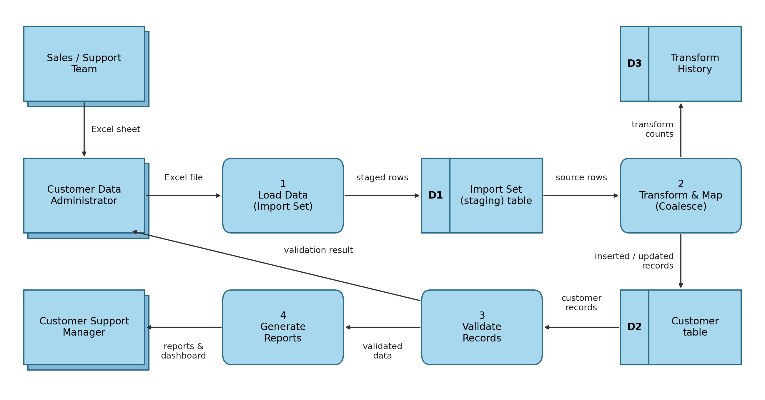
User Stories
The user stories below list the requirements for importing spreadsheet data into ServiceNow using Import Sets and Transform Maps.
User Type | Functional Requirement (Epic) | User Story Number | User Story / Task | Acceptance criteria | Priority | Release
Customer Data Administrator | Table & Data Setup | USN-1 | As a customer data administrator, I can create a custom customer table in ServiceNow (e.g., Customer Test). | The table appears under Tables and can be opened from the application menu | High | Sprint-1
Customer Data Administrator | Table & Data Setup | USN-2 | As a customer data administrator, I can add the customer fields (Customer ID, Name, Email, City, Account Type) with the right types. | All fields are visible on the table form and in the list view | High | Sprint-1
Customer Data Administrator | Table & Data Setup | USN-3 | As a customer data administrator, I can prepare an Excel sheet with a header row that matches the table fields. | The sheet has no blank cells or typos and a unique Customer ID for each customer | High | Sprint-1
Customer Data Administrator | Import Data | USN-4 | As a customer data administrator, I can upload the Excel file using System Import Sets > Load Data. | An Import Set table is created and a success message is shown | High | Sprint-1
Customer Data Administrator | Import Data | USN-5 | As a customer data administrator, I can open the staging table and check the loaded rows. | The row count in the staging table matches the sheet | Medium | Sprint-1
Customer Data Administrator | Transform & Mapping | USN-6 | As a customer data administrator, I can create a Transform Map from the Import Set table to the customer table. | The Transform Map is saved with the correct source and target tables | High | Sprint-2
Customer Data Administrator | Transform & Mapping | USN-7 | As a customer data administrator, I can map the source fields to the target fields using Auto Map Matching Fields and Mapping Assist. | Every column is mapped to the correct target field | High | Sprint-2
Customer Data Administrator | Transform & Mapping | USN-8 | As a customer data administrator, I can run the transform and check the Transform History. | The counts of inserted, updated and ignored rows are shown with a Success state | High | Sprint-2
Customer Data Administrator | Duplicate Prevention | USN-9 | As a customer data administrator, I can enable Coalesce on Customer ID so existing customers are updated instead of duplicated. | Importing the same sheet again inserts 0 new rows and ignores the rest | High | Sprint-2
Customer Data Administrator | Validation | USN-10 | As a customer data administrator, I can validate the imported records in the customer table. | Every record and column shows correctly in the list view | Medium | Sprint-3
Sales / Support Team Member | Data Submission | USN-11 | As a sales or support team member, I can send the latest customer data in an Excel sheet to the administrator. | The sheet includes all new and updated customers | Medium | Sprint-1
Customer Support Manager | Reporting | USN-12 | As a customer support manager, I can view a pie chart of customers by account type. | The chart shows correct counts with no duplicate customers | Medium | Sprint-3
Customer Support Manager | Reporting | USN-13 | As a customer support manager, I can view a bar chart of customers by city. | The chart shows correct counts for each city | Medium | Sprint-3
Customer Support Manager | Reporting | USN-14 | As a customer support manager, I can see the saved reports together on a dashboard. | The reports are available on one dashboard for the team | Low | Sprint-3
System Administrator | Security (Roles & ACL) | USN-15 | As a system administrator, I can create a role and assign it to a user. | The user shows the role under Roles | Medium | Sprint-3
System Administrator | Security (Roles & ACL) | USN-16 | As a system administrator, I can create ACLs that give read and write access to the customer table only to that role. | An impersonated user with the role can see and edit records, other users cannot see the table | Medium | Sprint-3

